**BOR ABQ 8: Workspace enhancement: Use middle mouse button to pan / RiverWare 7.2**  
Document Home: R:\doc\workspace\2017\MidButHandDrag\BorAbq8-MidButtonPan-Feature.docx  
Phil Weinstein, David Neumann, Edie Zagona, CADSWES, 12-28-2017

The RiverWare 7.2 workspace supports a temporary "Pan Mode" by pressing and dragging the middle mouse button (which is often a scroll wheel). When pressing and holding the middle mouse button, the cursor changes to the closed hand cursor, indicating that moving the mouse drags the content of the RiverWare workspace along with the cursor. When releasing the middle mouse button, the cursor reverts to the cursor for the current workspace mouse mode -- for Selection Mode this is the typical arrow pointer cursor.

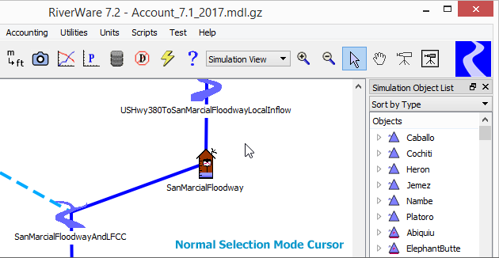

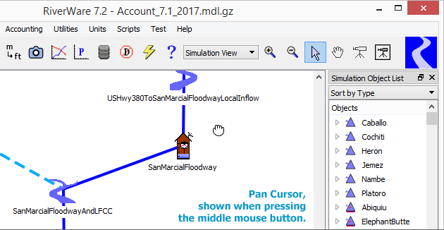

The new middle-button temporary pan mode is supported in all three Workspace canvases (Simulation, Geospatial, and Accounting) in the "Selection" and "Pan" workspace mouse modes. It is also supported in the new RiverWISE application's workspace viewer panel.

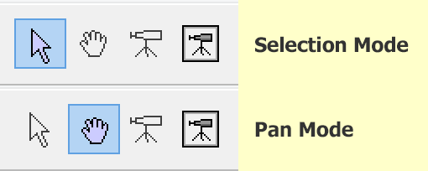

--- (end) ---