**RiverWare 7.2 Selection Statistics Enhancement: Time-Integrated Sum**  
Project: BOR Truckee LBAO 1.2 (Nov. 2017): Sum Flows to Volume  
Phil Weinstein, David Neumann, Edie Zagona, CADSWES, 11-07-2017  
Document Home: R:\doc\SlotDialogs\2017\BorLbao1p2-SumFlows-Feature.docx

The numeric statistics for the set of Slot / Timestep cell selections shown at the bottom of the Open Series Slot Dialog (and the new Slot Viewer) and the SCT now show a time-integrated sum for slots having "rate" units (i.e. units having an explicit "per-time" factor). Supported summations include:

* Summing Flow time series values to Volume
* Summing Power time series values to Energy
* Summing Velocity time series values to Length (distance)

The "integrated sum" value is shown using the active Unit Scheme's scale and unit for the time-integrated unit type (i.e. Volume, Energy or Length). This sum appears on the first of two selection statistics text lines:

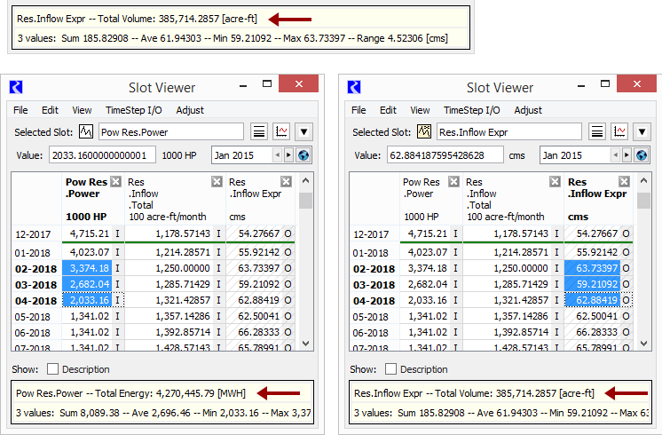

The integrated sum, and all selection statistics values are **updated dynamically** as the user changes the cell selection, e.g. by clicking in a cell, dragging along several adjacent slot/timestep cells, or clicking with the SHIFT or CONTROL key pressed to extend the selection or toggle the clicked cell into or out of the cell selection. The statistics for the current cell selection are updated dynamically also as the user edits the relevant unit type in the Unit Scheme editor. Statistics are presented only when the current slot/timestep cell selection includes only slots of having single unit type (e.g. Flow or Volume).

Note that the SCT did previously (prior to RiverWare 7.2) present an integrated sum statistic. But it was in units derived directly from the rate unit of the first selected slot, e.g. the integrated sum for "cfs" was f3 (cubic feet), scaled to show a value with a reasonable magnitude. With this enhancement, the SCT's integrated unit is now determined from the active unit scheme.

--- (end) ---