**Analysis for feature development questions from Greg Mueller, TVA (3-14-2017 e-mail).**  
Document Home: R:\doc\sct\2017\TvaEst\TvaSctEstMarch2017Rev1.docx  
Phil Weinstein, CADSWES, 3-16-2017 (a) – **SUPERSEDED, SEE Rev 2.**

Greg's questions are in two different aspects of the SCT:

1. Sharing SCT with Custom Slot/Timestep Cell Colors between different users, where saving the SCT is not feasible. Usability problem.
2. "Undocking" SCT Sheets (tabs).

## (1) Sharing SCT with Custom Slot/Timestep Cell Colors between different users, where saving the SCT is not feasible. Usability problem.

See these relevant feature documents:

* **SCT Custom Slot/Timestep Cell Colors / RiverWare 6.8**  
  R:\doc\sct\2015\SctCustomColors-2015-Sep.docx
* **SCT Series Value Threshold Exceedance Cell Color Alerts / RiverWare 6.9**  
  R:\doc\sct\2016\SctValueAlerts\SctValueAlertColors-Jan2016.docx

|  |  |
| --- | --- |
|  | http://cadswes2.colorado.edu/~philw/2017/SCT/TvaMarch/2017-03-16/SctApplyCustomColors.png |
|  | |

The accompanying screenshot illustrates applying a custom color to a selected set of slot/timestep cells within an SCT. (Note that the "Add Note..." operation, also discussed below, is enabled only for application to a single slot/timestep cell).

There are two, well encapsulated, major data structures used to represent the named color pairs (foreground/background), assignment of those color pairs to particular timesteps on particular series slots, and also value threshold information for the "conditional formatting" cell color function.

* Sim/UserFlagSet
* Sim/SlotUserFlagMap

One instance of each is currently saved in the SCT, so after applying custom colors to SCT cells, the SCT must be saved for the assigned cell colors to be viewable in a different RiverWare session (possibly by a different user). Unfortunately, re-saving the SCT is not readily doable in an important TVA RiverWare application.

These two data structured could easily be deployed within a model file instead of in an SCT. (This possibility was anticipated when these classes were originally developed). That's the first possible approach to address this problem outlined below.

**Here are two possible approaches** to address the requirement of having SCT custom cell colors applied in one RiverWare session available to different users in other sessions.

1. Develop an option to have an SCT use the UserFlagSet and SlotUserFlagMap instances associated with the RiverWare model file (as suggested above).
2. Retool the Series Notes capability for cell coloring instead of note-icon ornamentation, and provide a streamlined interface to create and apply those notes within an SCT.

### (1A) SCT option to use model-based UserFlagSet and SlotUserFlagMap data structures.

|  |  |
| --- | --- |
|  | http://cadswes2.colorado.edu/~philw/2017/SCT/TvaMarch/2017-03-16/SctConfig-Flags.png |
|  | |

The relevant classes are fully encapsulated, including XML serialization. It would be a very simple matter for the RiverWare model to maintain an instance of each of these which any given SCT could optionally refer to in place of its own instances of these things.

A natural place to present a "Store Custom Colors in Model File" checkbox would be in the "Flags" tab of the SCT Configuration dialog, under the "Custom Slot/Timestep Cell Colors..." button. (See the RiverWare 7.0 version of this dialog tab to the right).

Some implementation considerations:

1. The state of that checkbox would itself be stored in the SCT configuration file, so this does involve a minor addition to the SCT's Flex/Bison-parsed serialization.
2. The RiverWare model file would always retain an instance of each of these structures.
3. After loading an SCT which has its own definitions, if the user changes that SCT to instead "Store Custom Colors in the Model File", some work will be needed to do something reasonable to merge those definitions with any that are already in the model file. (This could involve some user interaction).

**(1A) Estimates (Phil, 3-16-2017):**

* **10.0 Hours** -- Basic operation, w/o attempting to merge two sets (an SCT's and the model's).
* **8.0 Hours** -- Interactive algorithm to merge an SCT's set with the model's set.

### (1B) Retool the Series Notes capability for cell coloring instead of note-icon ornamentation, and provide a streamlined interface to create and apply those notes within an SCT.

|  |  |
| --- | --- |
|  | http://cadswes2.colorado.edu/~philw/2017/SCT/TvaMarch/2017-03-16/SeriesNoteInSCT.png |
|  | |

Prior to the introduction of SCT Custom Slot/Timestep Cell Colors in RiverWare 6.8, RiverWare supported "Series Notes" which can be placed on individual timesteps within particular series slots. The data for those notes and "associations" of notes to particular slot/timesteps is stored in the RiverWare model file. This is currently available, but the current user interface is quite cumbersome, involving the need to view and operate two rather complex-looking dialogs just to apply a note to a slot/timestep.

We could develop an option for Series Note display to override a cell's background color instead of showing an icon-ornament in the slot/timestep cell.

The following screenshots demonstrate the complexity of the current implementation. Applying a new note to a timestep involves four operations using four different dialogs, as demonstrated in the following image. Applying an already-defined Series Note to a new slot/timestep cell requires only steps (3) and (4).

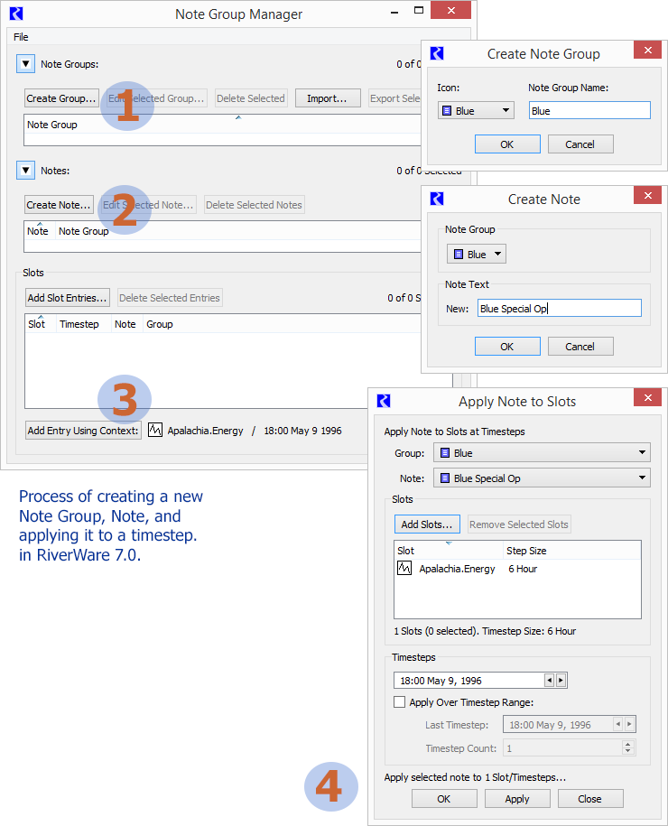

Once a Series Note has been placed on a slot/timestep cell, it can more easily be copied to other cells, as illustrated below.

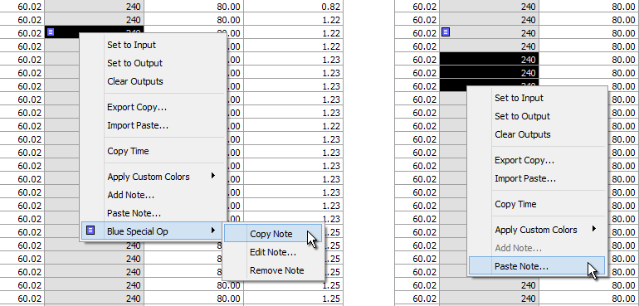

The design of more natural way of placing a set of pre-configured Series Notes (or **Series Note Background Colors**) could be implemented, analogous to the treatment of SCT custom slot/timestep cell colors.

Some implementation considerations:

1. Series Notes don't currently, themselves identify a color suitable for a cell background (over which numeric text would be readable). That would need to be added.
2. We could automatically define a special SCT color note group which would contain the limited set of notes supported by a more streamlined application to SCT cells. (A slightly confusing thing would be that the colors of Series Note icons are currently assigned to whole "note groups" rather than to individual notes).
3. It would be natural for "Series Note Background Colors" to apply to other series data displays -- in particular, the Open Series Slot Dialog.

**(1B) Estimates (Phil, 3-16-2017):**

* **8.0 Hours**-- Feature Design
* **24.0 Hours** -- Development (approximate, depending on the design).

|  |
| --- |
| **NOTE:** A more detailed analysis and estimate for enhancing Series Notes in provided in the *subsequent iteration of this document*: R:\doc\sct\2017\TvaEst\TvaSctEstMarch2017Rev2.docx (3-18-2017). http://cadswes2.colorado.edu/~philw/2017/SCT/TvaMarch/notes3.html |

## (2) "Undocking" SCT Sheets (tabs).

Here is the Greg Mueller's [TVA] description of a desirable feature. [3-14-2017 e-mail]:

* Is it feasible to change ... worksheets in an SCT such that individual tabs in an SCT can be "undocked" similar to how tabs in Internet Explorer or FireFox can be undocked? (Leads have asked me this question in the past and I am not sure if I have asked it of you). I don’t see us using a “redocking feature to combine individual SCTs in a since SCT but that could be useful from a development stance if a person could swap worksheets in and out. Again... for this, I am just curious about feasibility ....

A way of roughly accomplishing the requested behavior would be to create a 2nd SCT from the slots on the selected (possibly dragged) SCT Sheet tab. Any solution which uses that as the basis of the implementation (possibly hiding certain features of the "copy") would be quite easy to develop.

Alternatively, if the torn off sheet is an entirely different sort of thing (not itself actually an SCT, as such), we would need to understand more precisely what we are trying to accomplish.

Note that, currently -- in RiverWare 7.0 -- it is very easy to **copy the contents of an SCT Sheet tab from one SCT to another,** using context menu operations on the "Edit Series Slot List" tab. This is illustrated below. Also, the SCT's File menu has a "New SCT ..." operation; this creates a new SCT, opened to the Edit Series Slot Tab. So the behavior we are considering here is currently doable (in RiverWare 7.0), with basically ten (10) clicks. This at least demonstrates that the pieces to accomplish a higher level operation to support this feature are already in place. In any case, this does provide a way of recombining several separate SCTs into a single SCT. We could also provide higher level operations for that work flow, i.e. copying or moving sheets directly using context menu or drag operations directly on SCT Sheet tabs.

**Estimates (Phil, 3-16-2017):**

* **8.0 Hours** -- Basic operation -- using context menu operations of an SCT Sheet tab -- of copying or moving the contents of an SCT Sheet tab to a new SCT. The new SCT would have the same configuration and state of the original SCT except for the list of series slots. (We would probably also erase the content of the ancillary SCT tabs from the new SCT: Scalar Slots, Object Grid, and such).
* **12.0 Hours** (additional) -- Drag and Drop of SCT Sheet tabs between SCTs. (some tricky Qt coding).

See illustration below.

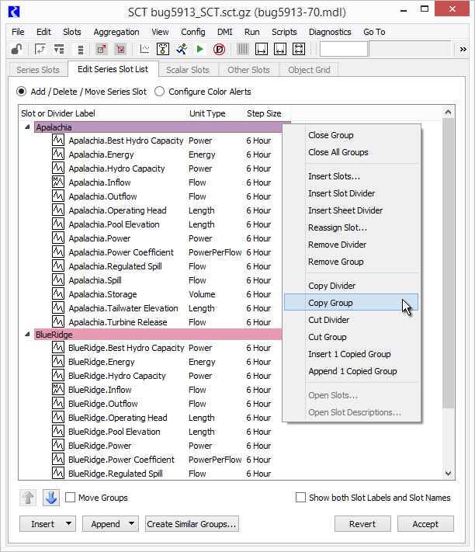

## Appendices

**Original Slot Text Annotations (Series Notes) Documentation**

* **Slot Text Annotations in RiverWare 5.2 -- User Notes** (June 2009)  
  R:\doc\guiGeneral\Annotations\SlotAnnotations2009UserNotes.fm [[PDF](http://cadswes2.colorado.edu/~philw/2017/SCT/TvaMarch/ref/SlotAnnotations2009UserNotes-2009jun22.pdf)]
* **Slot Text Annotations in RiverWare 5.2 -- Internal Design** (May 2009)  
  R:\doc\guiGeneral\Annotations\SlotAnnotations2009UserNotes.fm [[PDF](http://cadswes2.colorado.edu/~philw/2017/SCT/TvaMarch/ref/SlotAnnotations2009InternalDesign-2009may24.pdf)]

**SCT Custom Slot/Timestep Cell Colors Documentation**

* **SCT Custom Slot/Timestep Cell Colors / RiverWare 6.8** (Sept 2015)  
  R:\doc\sct\2015\SctCustomColors-2015-Sep.docx [[PDF](http://cadswes2.colorado.edu/~philw/2015/SCT/SctCustomFlags/SctCustomColors-2015-Sep-Phil-9-28.pdf)]
* **SCT Series Value Threshold Exceedance Cell Color Alerts / RW 6.9** (Jan 2016)  
  R:\doc\sct\2016\SctValueAlerts\SctValueAlertColors-Jan2016.docx [[PDF](http://cadswes2.colorado.edu/~philw/2016/SCT/ThreshColors/SctValueAlertColors-Jan2016-Phil-18.pdf)]

**Sample UserFlagSet and SlotUserFlagMap in SCT Config serialization**

User Flag XML in Flex/Bison-parsed SCT grammar. [RiverWare 7.0]  
[Related Images](http://cadswes2.colorado.edu/~philw/2017/SCT/CustCellColors/) (http://cadswes2.colorado.edu/~philw/2017/SCT/CustCellColors/).

USER_FLAG_SET XML-UFLAG-SET-BEG  
<UserFlagSet>  
 <UserFlagDef bgEna="1" fgEna="1" fgColor="#000000" label="E-Mergen-C" bgColor="#ff8074"/>  
 <UserFlagDef bgEna="1" fgEna="0" fgColor="#000000" label="Potato" bgColor="#aaaa7f"/>  
</UserFlagSet>  
XML-UFLAG-SET-END

SLOT_USER_FLAG_MAP XML-UFLAG-MAP-BEG  
<SlotUserFlagMap slotRecCnt="2">  
 <UserFlagSlotRecord slotName="Mead.Inflow" cellCnt="2" slotCol="-1" slotRecInx="0">  
 <UFS-Cell flag="Potato" dt="11-01-1993 00:00:00"/>  
 <UFS-Cell flag="Potato" dt="12-01-1993 00:00:00"/>  
 </UserFlagSlotRecord>  
 <UserFlagSlotRecord slotName="Mead.Outflow" cellCnt="2" slotCol="-1" slotRecInx="1">  
 <UFS-Cell flag="Potato" dt="11-01-1993 00:00:00"/>  
 <UFS-Cell flag="Potato" dt="12-01-1993 00:00:00"/>  
 <ThresholdSpec valType="N" threshInx="0" intervalName="Normal">  
 <NumValue unitType="Flow" scale="1" unit="acre-feet/month" val="800000"/>  
 </ThresholdSpec>  
 <ThresholdSpec valType="N" threshInx="1" intervalName="Oops" flag="E-Mergen-C">  
 <NumValue unitType="Flow" scale="1" unit="acre-feet/month" val="0"/>  
 </ThresholdSpec>  
 </UserFlagSlotRecord>  
</SlotUserFlagMap>  
XML-UFLAG-MAP-END

--- (end) ---