Object Viewer Revisions for RiverWare 7.2 / Dec 2017  
Document Home: R:\doc\openObject\2017\ObjViewerRevForRw72.docx  
Phil Weinstein, David Neumann, Edie Zagona, CADSWES, 12-06-2017.

### Object Viewer Enhancements for RiverWare 7.2

With some experience using the new Object Viewer (7.1) we've identified the need for several usability enhancements. The following changes have been developed for RiverWare 7.2.

The **Object Viewer's** set of simulation object tabs is now persistent within the RiverWare session. The Object Viewer can be closed, and reopened using a new "Object Viewer" button on the bottom of the RiverWare workspace. When reopening the Object Viewer, it will have the same set of object tabs it had when the viewer was closed (unless any of those simulation objects have been deleted).

http://cadswes2.colorado.edu/~philw/2017/ObjSlotViewerRev/2017-12-05/Workspace-StatusBar.png

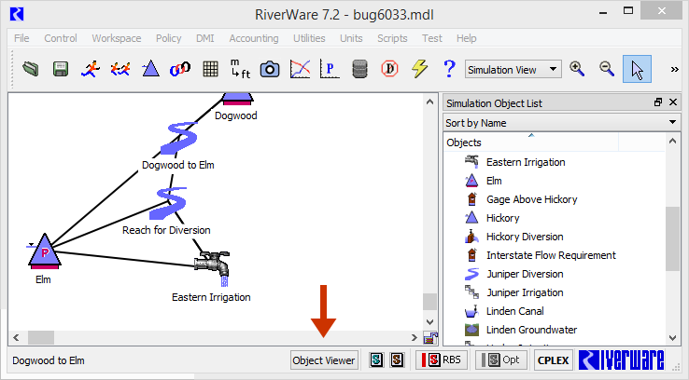

The Object Viewer button is enabled only if at least one simulation object (tab) is present -- or was present, the last time the Object Viewer was shown. Otherwise, the Object Viewer can be shown by "opening" a simulation object (e.g. by double clicking an object icon in the workspace).

Note: We originally planned to allow the Object Viewer to be shown "empty", i.e. without any simulation object tabs. But we ran into some technical difficulties with the "empty" state. For this reason, the new Object Viewer button needs to be disabled when the Object Viewer's object tab list is empty.

One new operation was added to the Object Viewer. File >> "Remove All Objects and Close" closes the viewer, and erases its persistent object tab list. If instead the user chooses "Close Window", or clicks the Red-X button in the window's titlebar, the current set of object tabs will be restored the next time the Object Viewer is shown.

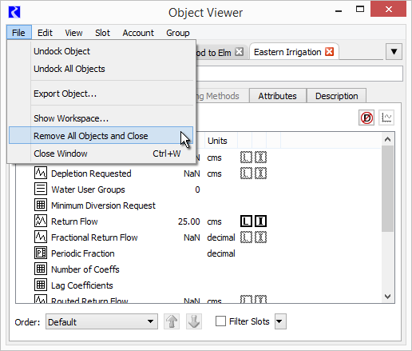

When removing an object tab from the Object Viewer or closing an Open Object Dialog, IF there are any Open Slots for that object -- either in their own Open Slot Dialog or in the Slot Viewer -- the following "Close Slots Too?" popup dialog is presented:

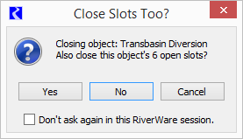

* If the user clicks "Yes", Open Slot Dialogs are closed, and slot columns are removed from the Slot Viewer for any slots on the Object being closed.
* If the user clicks "No", then only the Object is closed.
* If the user clicks "Cancel", then the Object remains open.

If the user checks the "Don't ask again ..." checkbox, then the last Yes/No answer provided by the user is used for all subsequent queries, without showing this popup dialog -- for the remainder of the current RiverWare session. However, that choice is ignored if the user clicks "Cancel" or closes this query dialog by clicking the Red-X window titlebar button.

### Technical

The list of simulation objects shown in the Object Viewer, as object tabs, is now represented within a new data model class: Sim/ObjViewerConfig. A single instance is maintained in Sim/SimWS (the SimWorkspace class). The ObjViewerConfig state is NOT saved in the RiverWare model file.

The "Close Slots Too?" popup dialog is implemented with a new OpenObjectDlg::QueryCloseAlsoSlotsDlg class, a QDialog subclass. The public interface is limited to the following single static "query" method. Of course, the query dialog is not actually constructed and shown if the user has already checked the "Don't show this dialog again" checkbox. This class effects the closure of the object's slot dialogs (or slot columns in the Slot Viewer) when the user clicks the "Yes" button.

// return indication: continue with object close.  
static bool OpenObjectDlg::QueryCloseAlsoSlotsDlg::query (SimObj* refObj);

---