**USACE SWD 9: Editing Multiple Curves and Plots / RW 7.1 / Feature**  
Document Home: R:\doc\plotting\2017\CoeSwd9-EditMultiPlotsCurves-Feature.docx  
Phil Weinstein, David Neumann, Edie Zagona, CADSWES -- 3-14-2017, minor edits: 3-15-2017.

## Overview

RiverWare 7.1 provides an enhancement to plot page configuration which centralizes editing controls from various single-item editor dialogs into a unified multiple-item editor. Most settings for a plot page’s supported nine separate plots are editable within the new **Configure Multiple Plots and Curves** dialog. The user can select multiple items in a plot page, e.g. curves and markers, and apply selected settings to those items in a single operation.

The Configure Multiple Plots and Curves Dialog supports three editing modes.

1. Curves (and Markers)
2. Axes
3. Background (including Grid)

The choice of editing mode determines:

1. The editing controls presented in a vertically scrollable panel.
2. The active items -- Plots or Curves and Markers -- presented within a table of plot items.

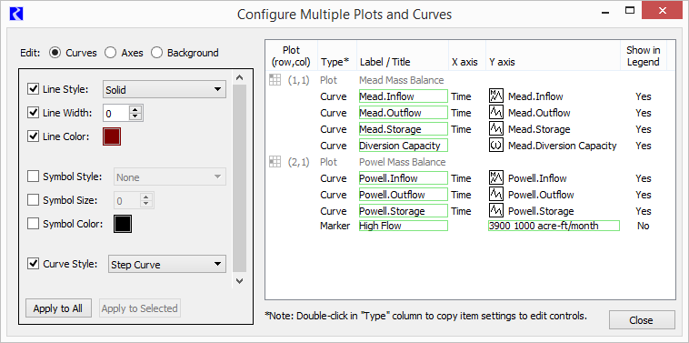

Groups of related settings -- or, in some cases, individual settings (as for the "Curves" settings illustrated above) within the vertically scrollable editing controls panel can be individually enabled for application to the selected (or all relevant) items within the plot item table.

Apart from the setting operations supported in the editing controls panel, operations within the plot item list include:

1. Direct editing of plot titles, and curve and marker labels.
2. Direct editing of a markers' horizontal and vertical values.
3. Replacement of a curve's slots with a slot picked using the general slot selector.
4. Copying the selected curves' or plots' slots to the slot clipboard.
5. Showing the Slot Dialog for a slot in a slot curve.
6. Copying the setting values of a particular plot, curve, or marker to the editing controls panel.

**Not Implemented**

This initial implementation of the Configure Multiple Plots and Curves Dialog **does not** support the following capabilities:

1. Addition or deletion of curves and markers.
2. Editing of marker attributes which are not also common to curves.
3. Reordering curves and markers within a plot (to determine legend and drawing order).
4. Reconfiguring the number of, and arrangement of plots within the plot page.
5. Enhancement to allow individual curves and markers to be conditionally included in their containing plot's legend.
6. A “Sample” column in the plot item table to show the result of display attributes (e.g. for lines and symbols).
7. Slot *column* support for the curve slot replacement function.

## Configure Multiple Plots and Curves Dialog

The new Configure Multiple Plots and Curves Dialog is accessible from the Plot Page Editor dialog via an "Edit" menu operation, and via a new "Multiple" configuration button. *See the following screenshots.*

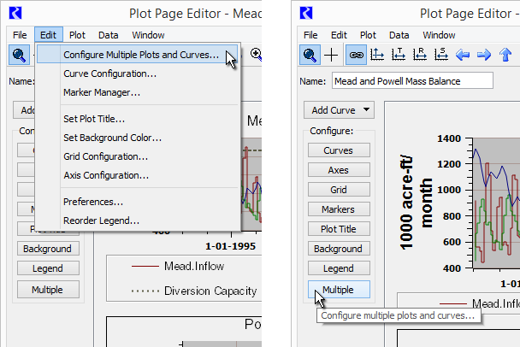

This dialog has three major panels:

1. **Edit Modes radio buttons:**Curves, Axes, and Background
2. **Setting Edit Controls:**vertically scrollable panel
3. **Plot Item Table,**with items for plots, curves and markers.

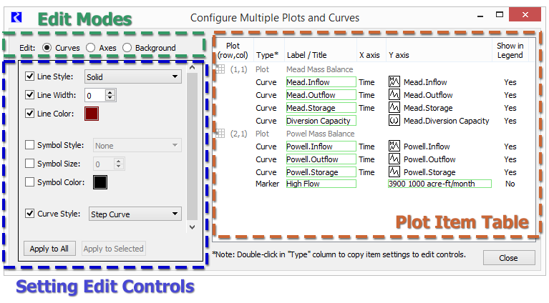

Directly editable cells within the plot item table are indicated with a green border. Double clicking on such cells starts an in-cell edit:

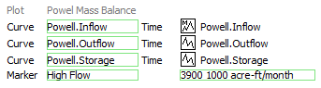

Edit operations -- either direct edits within the Plot Item Table OR setting changes applied when clicking the "Apply to All" or "Apply to Selected" buttons in the Setting Edit Controls panel -- are applied to the plot page being edited in the **Plot Editor Dialog**. In that dialog, the user can either accept ("OK" or "Apply") those changes, or can discard ("Cancel") those changes.

Clicking the "Apply to All" button shows a confirmation dialog; see the following example.

## http://cadswes2.colorado.edu/~philw/2017/CoeSwd9/DocImages/ApplyAllConfirm.png

## Curve and Marker Editing

In "Curves" edit mode, the curve and marker items within the plot item table are active. Double clicking on an item either starts an in-cell edit within the clicked cell or copies that curve’s or marker's setting values to the edit controls panel. Curves' and markers' label text and markers' values can be directly edited.



|  |  |
| --- | --- |
|  | http://cadswes2.colorado.edu/~philw/2017/CoeSwd9/DocImages/Old-CurveConfigDlg.png |

All of the setting operations provided in the old **Curve Configuration dialog** (shown to the right) are supported in the new Configure Multiple Plots and Curves Dialog.

Various operations on curves and markers are supported with a context (right-click) menu:

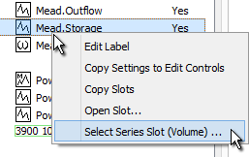

* **Edit Label**-- initiates an in-cell edit in the "Label / Title" column. Same as double-clicking in that column.
* **Copy Setting to Edit Controls** -- copies the values of the clicked item to the Setting Edit Controls panel. Same as double-clicking in a non-editable cell.
* **Copy Slots** -- copies the selected plot items' slots to the RiverWare slot clipboard. The full names of those slots are also copied to the system clipboard.
* **Open Slot...** -- shows the Open Slot Dialog for the clicked slot.
* **Select ... Slot** -- shows the general slot selector to replace a curve's slot with a different slot. Only a slot of the same type (e.g. "Series Slot") and unit type (e.g. "Flow") can be used.

|  |  |
| --- | --- |
|  | http://cadswes2.colorado.edu/~philw/2017/CoeSwd9/DocImages/Old-MarkerConfigDlg.png |

Current support for **marker editing** is limited to the settings which are also available for curves. This includes all setting operations provided by the old **Marker Configuration dialog**(shown to the right) and the Plot Marker Manager except for the following:

* **Marker Type:**Horizontal / Vertical / Cross
* **Label Alignment:** Left, Center, Right / Top, Center, Bottom
* **Axis Assignment:** Lower/Upper X Axis, Left/Right Y Axis.
* **"Display legend items for markers"** checkbox.

## Axis Editing

|  |  |
| --- | --- |
|  | http://cadswes2.colorado.edu/~philw/2017/CoeSwd9/DocImages/Settings2-Axis.png |

In the "Axes" edit mode, the plot items (not curve and marker items) within the Plot Item Table are enabled for selection.

The user also selects which of the four axes is to be modified among the selected plots (or all plots in the plot page) -- see the combo box at the top of the Setting Edit Controls panel.

Only those settings appropriate for the selected axis are presented. (DateTime axes support different settings).

All setting operations supported in the old Axis Configuration dialog (not shown) are supported in the new Configure Multiple Plots and Curves dialog.

Note that the first image to the right presents the recently developed capability (for RiverWare 7.1) for support of user specified scale and units for a numeric axis. See the "Axis Numeric Display" setting group.

|  |  |
| --- | --- |
|  | http://cadswes2.colorado.edu/~philw/2017/CoeSwd9/DocImages/Settings3-Background.png |

## Background Editing -- Background Color and Plot Grid

As with the "Axes" edit mode (see above), in the "Background" edit mode, the plot items (not curve and marker items) within the Plot Item Table are enabled for selection. Changes to plot background color and grid configuration can be applied to the selected plots -- or to all plots in the plot page.

All setting operations supported in the old Grid Configuration dialog (see below) are supported in the new Configure Multiple Plots and Curves dialog.

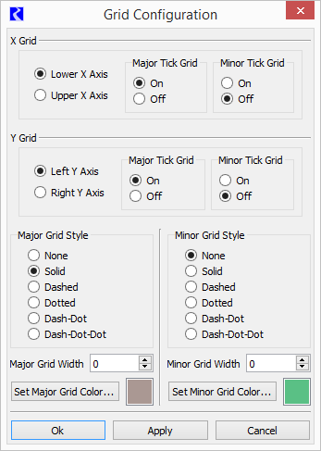

Note: During this development, a previously existing defect was discovered which prevented the grid from being aligned with the "other" axis in each dimension (i.e. the Right Y Axis or the Upper X Axis). This has been fixed for RiverWare 7.0.6 and 7.1 development. See Gnats 5923, "Alignment of plot grid with right axis is not working."

--- (end) ---