**Proposal: Streamlining the Process of Adding Series Notes in RiverWare 7.2**  
Phil Weinstein, David Neumann, Edie Zagona, CADSWES, 10-02-2017  
Document Home: R:\doc\SeriesNotes\2017\StreamliningNotes-Analysis.docx

**Overview**

In RiverWare 7.1 and recent prior versions, the process of adding a text note to a series slot timestep is quite involved. The user has to operate these two rather complex dialogs for what should be a simple operation:

1. Note Group Manager
2. Apply Note to Slots

Between these two dialogs, the user is presented with the following operations and information which is not needed to add a note to a slot timestep:

1. Buttons to Edit, Delete, Import, and Export Note Groups.
2. A list of other slots / timesteps to which one or more selected notes are currently applied.
3. Redundant widgets for selecting which note to apply.
4. Redundant widgets for selecting the timestep (DateTime) for adding the note.
5. Generally unnecessary provision to specify additional target slots.

The full capabilities of the Note Group Manager, and it's ancilliary "Apply Note to Slots" dialog are all meaningful, but not required for most situations where the user wants to add a single note to a single timestep on a series slot.

**Current "Add Note" Process and Dialogs**

The following sequence of operations are required to add an existing (defined) note to a Series Slot timestep (cell):

1. Right click on the desired Slot / Timestep cell
2. ... Select "Add Note..."
3. In the Note Group Manager  
   ... Select the desired Note Group (this determins the note's icon color)
4. ... Select the desired Note item
5. ... Click the "Add Entry Using Context" button
6. In the "Apply Note to Slots" dialog  
   ... Click the "OK" button
7. Close or Minimize the Note Group Manager

[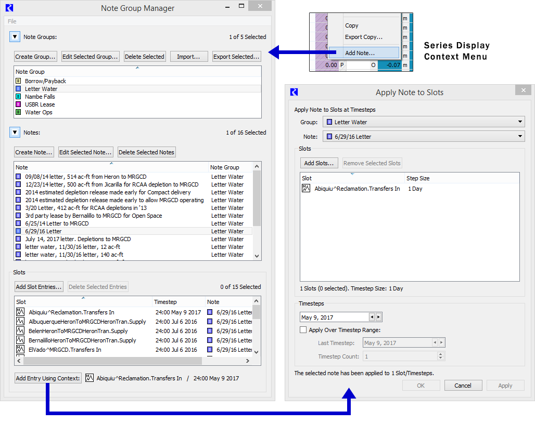](http://cadswes2.colorado.edu/~philw/2017/AccountNotes/StreamlineProp/ExistingDialogsMontage.png)

Use of the auxiliary "Apply Note to Slots" dialog allows the user to specify a different slot or set of slots, change the timestep (DateTime) and optionally specify a number of contiguous timesteps (i.e. more than one) to which the note will be added.

**Streamlined "Add Note to Slot" Dialog**

We propose presenting a simplified version of the Note Group Manager for the "Add Note" operation performed from a particular Slot and Timestep cell.

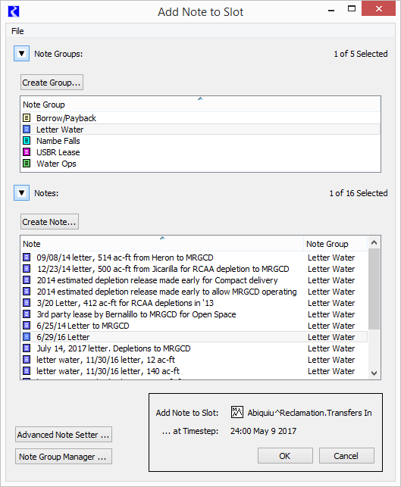

The new "Add Note to Slot" dialog is a modification of the Notes Group Manager, with the following differences:

* Removed "Group" Buttons: "Edit Selected Group", "Deleted Selected", "Import...", "Export Selected".
* Removed Note Buttons: "Edit Selected Note", "Delete Selected Note".
* Change to Notes List: Single (not multiple) Selection
* Removed: Slots panel. (In the manager, this shows all slots having the selected note items).
* Added Bottom Buttons:
  + OK -- assigns the single selected note to the indicated slot and timestep and dismisses this dialog.
  + Cancel -- dismisses this dialog.
  + "Advanced Note Setter..." shows the legacy "Apply Note to Slots" dialog, initialized with the selected Note Group, Note, Slot, and Timestep and dismisses this dialog.
  + "Note Group Manager..." shows the full Note Group Manager, initialized with the selected Note Group, Note.

**Minor Simplification of Note Group Manager**

Since the Note Group Manager will no longer be used as part the "Add Note..." process, its Slot and Timestep "Context" (shown along the bottom of the dialog) will be removed. Note that the "Add Slot Entries" button does also show the "Apply Note to Slots" dialog to apply a single selected note to possibly multiple slots on one or more contiguous timesteps.

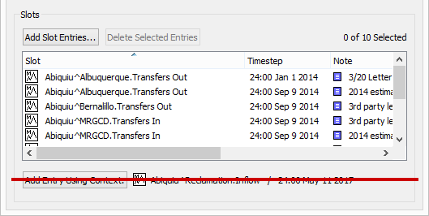

Additionally, we will elaborate the group box and button text in this panel:

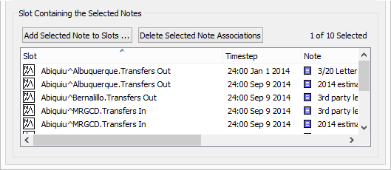

The "Add Slots Entries..." button will be changed to "Add Selected Note to Slots...". This has the same function as before: it shows the (advanced-) "Apply Note to Slots" dialog. (This button should be enabled only when a single note is selected in the Notes list, above this Slots panel). The "Delete Selected Entries" button will be changed to "Delete Selected Note Associations".

--- (end) ---