**Adding Note to Account MultiSlot: Option to Add Note to Supply / RiverWare 7.2**  
Phil Weinstein, David Neumann, Edie Zagona, CADSWES, 10-02-2017  
Document Home: R:\doc\accounting\2017\SeriesNotes\AddNoteToAcctSlotOrSupply.docx

This document describes a new option, in RiverWare 7.2, for adding series timestep notes to Account MultiSlots when that slot is linked to a Supply. This new provision applies to both "Adding" and "Copying and Pasting" series timestep notes.

Note: we have drafted a proposal to simplify the overall Add Note operation such that only a single dialog (beyond the new "Add Note" MutliSlot / Supply selector described below) would be required to add a note to a slot / timestep cell. See this document:

* **Proposal: Streamlining the Process of Adding Series Notes in RiverWare 7.2**R:\doc\SeriesNotes\2017\StreamliningNotes-Analysis.docx

**Enhanced "Add Note" Operation for Account MultiSlots**

In RiverWare 7.1 and prior versions, adding a note to an Account MultiSlot cell results in that note being visible only on that slot and not also the slot on the other end of a linked Supply. Sponsors have requested that there be options to instead place such a note on the *linked Supply* so that added notes do show up on both Account Slots linked through a Supply.

This choice is provided by initially showing a dialog having radio buttons for:

* The clicked Account MultiSlot
* Each of the Supplies linked to that Account MultiSlot

This "Add Note" radio-box dialog is shown only if the Account MultiSlot has at least one linked Supply. Clicking the "Continue..." button shows the Note Group Manager to continue the add note operation. As before, that dialog supports the selection of a Note Group and Note, and an "Add Entry Using Context" operation (initialized with the selected Account MultiSlot or Supply) to show the "Apply Note to Slots" dialog to confirm the timestep and optionally specify multiple contiguous timesteps, and complete the Add Note operation.

If the originally clicked Slot / Timestep cell in the Edit Account dialog is not an Account MultiSlot linked to at least one Supply, the "Add Note..." context menu operation goes right to the Note Group Manager to effect the add note operation.

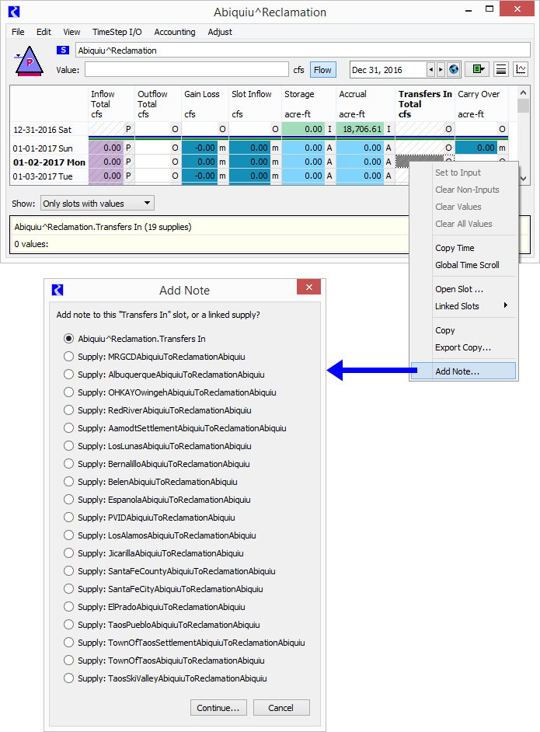

**Enhanced "Paste Note" Operation for Account MultiSlots**

Another way of adding notes to slot timesteps is through the "Copy Note" and "Paste Note" operations. This is more convenient than adding a note through the "Add Note..." operation if the desired note is available in a visible Slot / timestep cell.

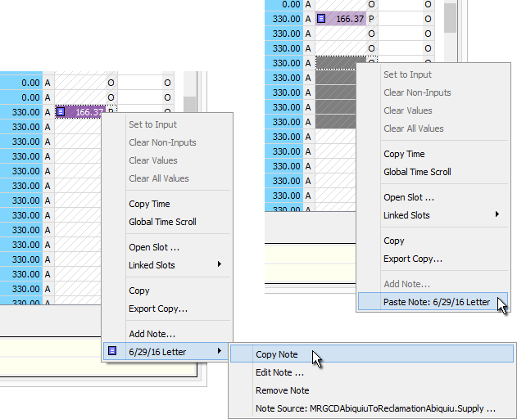

When pasting into an Account MultiSlot having linked Supplies, a variation of the new Slot / Supply (radio box) selector popup is shown, with the following differences:

1. The Window Title is "Paste Note" (instead of "Add Note").
2. The "Continue..." button is changed to "OK". This completes the Paste operation (rather than showing another dialog to effect an "Add Note" operation).

Note that the Paste Note operation can be applied to a mutliple Slot/timestep cell selection. The Slot / Supply (radio box) selector popup will be shown ONLY IF the cell selection is limited to a single slot. If cells in multiple slots are selection, the following dialog will be presented:

|  |  |
| --- | --- |
|  | http://cadswes2.colorado.edu/~philw/2017/AccountNotes/2017-09-27/PasteNoteToMultipleSlots.png |

--- (end) ---