**Initial Workspace View Appearance Configuration / RiverWare 6.7 / July 2015**  
Document home: R:\doc\workspace\2015\InitialWorkspaceViewAppearance.docx  
Phil Weinstein, David Neumann, CADSWES. Edit: 7-09-2015

This new configuration option in RiverWare allows the user to:

1. Optionally have a particular *specified* workspace view be initially shown after model load, i.e. instead of the view which had been shown at the time of the most recent model save operation. (Both options are supported).
2. Separately, for each of the three workspace views -- Simulation, Accounting, and Geospatial:
   1. Specify an initial zoom level.
   2. Choose between four different algorithms for the view's initial scroll position.

The configuration dialog for this feature is accessed via the RiverWare Workspace's "Workspace" menu. Clicking the "Initial Appearance..." menu item shows the Initial Workspace Appearance dialog.

|  |  |  |
| --- | --- | --- |
| http://cadswes2.colorado.edu/%7Ephilw/2015/Workspace/InitSettings/DocImages/WorkspaceMenu.png |  | http://cadswes2.colorado.edu/%7Ephilw/2015/Workspace/InitSettings/DocImages/Dlg3.png |

All changes made in this dialog are immediately recorded; there is no "Apply" operation. Closing the dialog with the window title bar's red "X" button is equivalent to clicking the "OK" button.

The **"Open Model in View" radio boxes** support these two options:

1. **"Last Saved Workspace View".** This is the default setting. It implements the prior behavior with respect to the initially shown view after loading a model. The current view at the time of the last model save is restored as the current view.
2. **"Specify View".** This setting causes the view selected in the view selection combo box (below the radio buttons, see image above) to become the initial workspace view when the model is loaded. Note that this combo box is used also within this dialog to switch the setting controls to the settings for one of the three views.

The Zoom level and Location algorithm settings are set independently for each of the three views. As just mentioned, the view for which these attributes are edited in this dialog box is set through the **view selection combo box.** Note that the "Accounting View" option is shown only if accounting is enabled in the RiverWare model.

The discrete zoom levels supported in the workspace can be selected within the **Zoom combo box.** "100%" is the normal zoom level. Currently, eleven (11) zoom levels are supported, ranging from 20% (zoomed out) to 400% (zoomed in).

The user can select between these four "Location" settings (as indicated above, separately for each of the three workspace views):

1. Lower Left Corner
2. Last Save Location
3. Center-Most Object
4. Center on Object:  
       <object type icon> <object name> [...] - *ellipsis button showing the object selector*

* The **"Lower Left Corner"** option causes the workspace view to be initially scrolled to the bottom left.
* The **"Last Save Location"** option preserves the workspace coordinates which appeared at the *center* of the visible area of the scrolled workspace, as it is at the time of the model save. Note that the *size* of the workspace window persists with user login account-based settings, i.e. apart from the model-based view settings edited in this dialog.
* The **"Center-Most Object"** option generally* places -- at the *center* of the workspace window -- the object which is closest to the "average" workspace view location of all visible object icons.
* The **"Center on Object"** option generally* places the specified object at the *center* of the workspace window. When this option is selected, the associated elippsis button brings up the object selector to specify the center object. See the image below.

*When "centering" on an object, if the object is near one of the edges of the view's canvas dimensions (within a "half screen"), the view is scrolled such that the object is visible, but not actually centered, as such. This is implemented with just the default behavior of the Qt4 QGraphicsView::centerOn (const QGraphicsItem*) method.

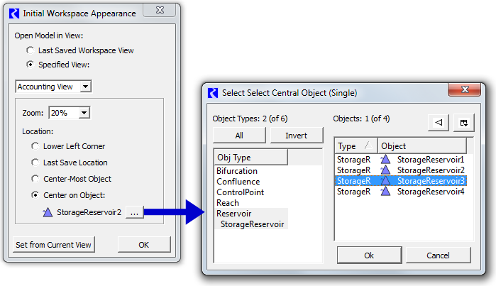

The initial Zoom and Location algorithm settings are applied (when reloading the model file) regardless of which of the two "Open Model in View" modes is selected. In particular, choosing the "Last Saved Workspace View" option (which implements the prior behavior with respect to which view is initially shown) still allows the configured zoom level and initial location algorithm to be applied (but of course those properties will be those associated with the workspace view being shown -- not related to the view combo box setting in this dialog).

Clicking the **"Set from Current View"** button has these three effects:

1. The view selection combo box is set to the Workspace's actual current view. Any changes to the subordinate Zoom and Location settings made for a different view are automatically saved -- (technically, they already had been saved). This action of switching this combo box has the effect of loading the previously saved Zoom and Location settings into the corresponding widgets, but these values are immediately overridden as follows.
2. The Zoom combo box is set the current view's zoom level.
3. The Location setting is set to "Last Save Location".

The **OK button** dismisses the dialog.  (Setting values are actually applied to the data model as soon as widget selections are made).

A special function of the OK button is useful for immediately seeing the effect of the initial workspace view configuration setting. Holding down the **SHIFT key** while clicking the **OK button** applies the current setting values to the workspace. This demonstrates how the workspace will look after the model is reloaded -- assuming the current state of the workspace, i.e. as if the save operation was done immediately after dismissing this dialog. When clicked in this way (with the SHIFT key held), the dialog is *not* dismissed. This feature is indicated with a tooltip on the OK button: **"Shift Click: Apply now to workspace".**

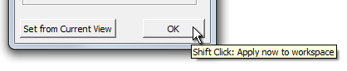

--- (end) ---