**Slot Dialog Display Preferences for RiverWare 6.8**  
Phil Weinstein, David Neumann, CADSWES, edit 10-13-2015   
Document Home: R:\doc\SlotDialogs\2015\Preferences\SlotDlgPrefs-2015Oct.docx

|  |
| --- |
| http://cadswes2.colorado.edu/%7Ephilw/2015/SlotDlg/Prefs/SlotDlgPrefs-2015OctImages/SlotDlg2.png |

Before this enhancement, e.g. in RiverWare 6.7 and prior versions, the following Slot Dialog settings had effectively been cleared each time a Slot Dialog was re-shown (other than just being *minimized* and subsequently *restored*):

1. Show Selection Statistics
2. Show "Notes" Column
3. Show Description Panel

That is, those features (*see image to the right*) had been hidden each time the Slot Dialog was re-shown.

With this enhancement, there are global settings, saved with the RiverWare Model, which provide preferences applied each time a slot dialog is re-created. The "Notes" and Description Panel preferences have an option to show the feature only if the slot contains notes or a description.

Note: Currently, Selection Statistics and Notes are supported only on Series Slots. They are not supported on Table Slots or Scalar Slots.

With this enhancement, the initial (preferred) states of these settings (i.e. the initial visibility of the three indicated Slot Dialog features) are configurable by the user. These preferences are saved with the RiverWare model and are edited with the "Slot Dialog Display Preferences" configuration dialog:

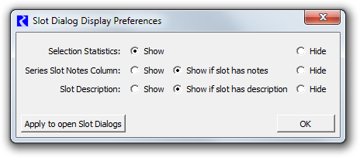

The "Series Slot Notes Column" setting includes an option to show the "Notes" column only if the slot has any associated notes. Similarly the "Slot Description" setting has an option to show the Description panel only if the slot has a description provided by the user.

As an added feature, the preferences can be immediately applied to all currently open slot dialogs by clicking the "Apply to open Slots Dialog".

The "Slot Dialog Display Preferences" configuration dialog is accessible from two places:

1. The Workspace's Workspace >> Slots submenu.
2. The Slot Dialog's View menu (for Series Slots and Table Slots only).

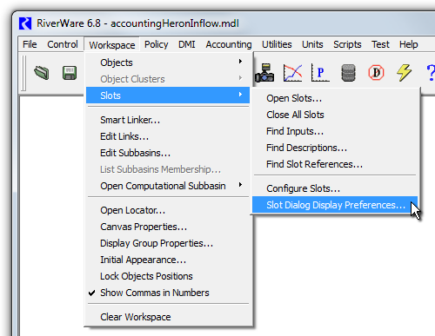

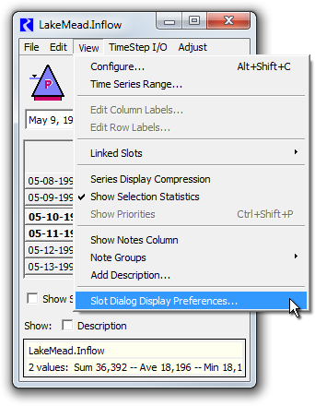

**Technical:** These global preferences are saved in the RiverWare model file using an XML serialization. Here is an example:

|  |
| --- |
| <SlotDlgPrefs>   <ShowSelStatus show="0"/>   <ShowNotes show="P"/>   <ShowDesc_General show="P"/> </SlotDlgPrefs> |

The supported "show" XML attribute values in the XML illustrated above are "0" (zero, off), "1" (one, on), "P" ("if Present").

--- (end) ---