**RPL Predefined Function Help content in RiverWare 6.7 / March 2015**  
Phil Weinstein, David Neumann, Patrick Lynn, Edie Zagona, CADSWES   
Edit: 3-16-2015, Phil, *ready for review.*

**Overview**

RiverWare 6.7 displays RPL Predefined Function Online Help Content -- as HTML in a QWebView -- in the following three dialogs:

1. **Predefined Function Editor** dialog.
2. **RPL Palette** ... on the "Predefined Functions" tab when Descriptions are shown.
3. **RPL Set Editor** ... when "Show Predefined Groups" and "Show Descriptions" are checked.

|  |  |
| --- | --- |
|  | http://cadswes2.colorado.edu/%7Ephilw/2015/RplDoc/FeatureImages-March2015/DoubleClickFunctionOld.png |

Prior to this enhancement, panels and dialogs which normally show a user-provided description for a RPL Function, in the case of RPL *Predefined* Functions, showed either a blank panel or the message, "See Online Help for documentation of predefined functions". (*See the accompanying image*).

These panels now show an HTML version of online documentation for the particular RPL Predefined Function.

Also, a Description panel was added to the RPL Palette's "Predefined Function" Tab, similar to, and controlled in parallel with the visibility of the "Description" panel on the "User-Defined Functions" tab.

The Function HTML help content -- for all, approx. 200 RPL Predefined Functions -- is bound to the RiverWare executable as a Qt Resource. (A compressed copy of the full HTML page -- without images -- is part of the RiverWare executable). Referenced images are loaded at run time by RiverWare's integrated QWebKit browser.

The following document describes the technical process of integrating this help content into the RiverWare build:

* Processing RPL Predefined Function Help for use in the RiverWare 6.7 Build  
  R:\doc\onlineHelp\process\GenRplFuncContent.html   
  R:\doc\onlineHelp\process\GenRplFuncContent-March2015.pdf

**The RPL Predefined Function Help viewer panel**

The new help content is displayed in a new Qt4 QWebKit-based integrated web browser deployed as a panels where a RPL Predefined Function "context" is available. The HTML content has a "responsive" layout, displaying well regardless of the available width for the panel.

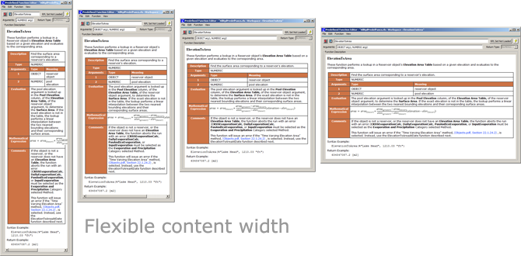

Math formulas are currently implemented as images (JPEG), and are not currently scalable. Care was taken to insure that those images don't impose a minimum width on the containing table. If the available width does not accommodate the image width, then the image extends beyond the right side of the content. The obscured part of such images can be seen either by horizontal scrolling or enlarging the width of the containing dialog's window.

In this initial implementation, hyper-links within the displayed content are not operational. (Where we were able to do so with our automated publishing process, associated link text -- e.g. "Click Here" -- has also been removed).

|  |  |  |  |  |  |
| --- | --- | --- | --- | --- | --- |
| The initial implementation of the viewer panel supports these two context menu operations:   |  |  |  | | --- | --- | --- | | * Copy * Print... |  | http://cadswes2.colorado.edu/%7Ephilw/2015/RplDoc/FeatureImages-March2015/ContextMenu2.png |   The "Copy" operation copies the selected text, as just plain text (not HTML).  If a PDF printer driver is installed on the system, a RPL Predefined Function's help content can be printed to a PDF file. The screenshot to the right shows such a PDF as viewed in Adobe Reader. |  | http://cadswes2.colorado.edu/%7Ephilw/2015/RplDoc/FeatureImages-March2015/PrintPdf.png |

|  |  |
| --- | --- |
|  | http://cadswes2.colorado.edu/%7Ephilw/2015/RplDoc/FeatureImages-March2015/EditPredefFuncDlg_ElevToArea.png |

**Predefined Function Editor dialog**

The Predefined Function "Editor" dialog now displays the help content for the particular function.

As mentioned above, this is in place of the message which used to be displayed (before RiverWare 6.7) ... *"See Online Help for documentation of predefined functions".*

**RPL Palette**

|  |  |
| --- | --- |
|  | http://cadswes2.colorado.edu/%7Ephilw/2015/RplDoc/FeatureImages-March2015/RplPalette1-WithDesc.png |

With this enhancement, both the User-Defined Functions and the Predefined Functions tabs in the RPL Palette optionally show a "Description" panel. As before, this panel on the User-Defined Functions tab shows an editable, user-provided function description. The panel on the Predefined Functions tab shows the corresponding help content.

The Description panels on those two tabs are shown using the single "Show Descriptions" checkbox under the "Function Menu" (*see below*).

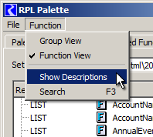

When the description panel is shown, navigating through the Predefined Functions list with the up and down arrows instantly and rapidly displays the newly selection function's help content in the Description panel.

|  |  |
| --- | --- |
|  | http://cadswes2.colorado.edu/%7Ephilw/2015/RplDoc/FeatureImages-March2015/RplSetEditor-FuncHelp1B.png  http://cadswes2.colorado.edu/%7Ephilw/2015/RplDoc/FeatureImages-March2015/RplSetEditor-FuncHelp2.png |

**RPL Set Editor**

RPL Predefined Function Groups can optionally be included in the tree of RPL Groups and their contained RPL block items. (See the first accompanying screenshot).

When "Predefined Groups" *and* the optional Selected Description panel are shown -- and when a RPL Predefined Function is selected, the associated help content is displayed in the Selected Description panel.

As with the RPL Palette (see above), navigating through the Predefined Functions list with the up and down arrows instantly and rapidly displays the newly selection function's help content in the description panel.

--- (end) ---