RiverWare 6.5: Printing Plots:   
 User Configurable Headers and Footers

|  |  |  |
| --- | --- | --- |
| This document describes a new capability in RiverWare to configure headers and footers generated in printed plot output.  For each corner of the printed page, the user can choose between several types of content, including user-supplied text. |  | http://cadswes2.colorado.edu/%7Ephilw/2014/BorTruckee/PrintPlotHeaders/2014-03-27/dlg3.png |

In RiverWare 6.4 and earlier versions, plots unconditionally included header and footer text in all four corners of the printed page. Here is an illustration:

|  |  |  |  |  |  |  |  |  |  |  |  |  |
| --- | --- | --- | --- | --- | --- | --- | --- | --- | --- | --- | --- | --- |
| |  |  |  | | --- | --- | --- | | RiverWare 6.4 Plot: Abiquiu InOut |  | RiverWare 6.4 Model: accountingRules.mdl | |  |  |  | |  |  |  | | Model saved: 13:50 January 6, 2012 |  | Printed: 14:46 March 31, 2014 | |

In RiverWare 6.5, Plot Pages now have an associated configuration for the headers and footers included in printed output. For EACH of the four corners of the printed page, the user can choose between these options:

1. None
2. Custom -- *user supplied text*
3. Plot Name -- *either Plot Page Name or single-plot's Plot Title*
4. Model Name
5. Model Save Date
6. Print Date

The latter four options generate the same text as before (but can be assigned to any of the four corners).

A new "Printed Header/Footer Configuration" dialog is accessed via the File >> Print submenu:

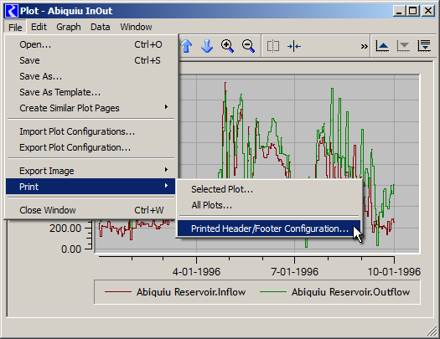

Although the configuration dialog is accessed via the File >> Print submenu, the header/footer configuration settings are associated with the saved plot page.

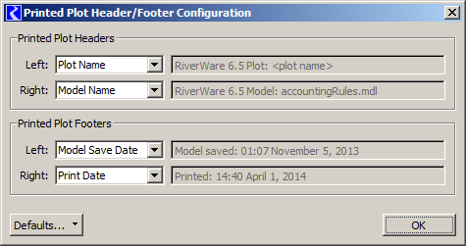

Note: The text generated for the "Plot Name" content type depends on the operation with which the plot print was initiated. As illustrated above, these two "Print" operations are supported from the Plot Dialog:

1. File >> Print >> Selected Plot ...
2. File >> Print >> All Plots...

When the "Selected Plot" operation is used, the Plot Name is the selected plot's Title.

When the "All Plots" operation is used, the Plot Name is the name of the Plot Page (i.e. the name with which the Plot Page is saved within the RiverWare Model). If the Plot Page has not yet been saved, the page's name is "Unsaved Plot".

This distinction applies even if the Plot Page has only a single Plot.

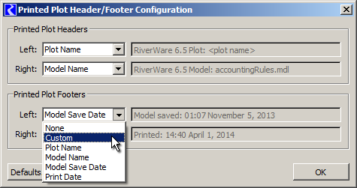

The configuration dialog supports these Default operations:

1. Apply User Default
2. Apply Standard Default
3. Save As User Default ... (*with user confirmation*).

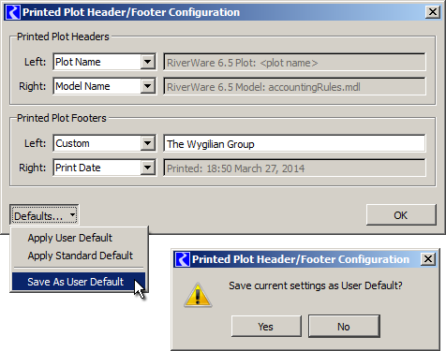

The "Standard Default" provides the same functionality as prior RiverWare versions (6.4 and earlier).

The "User Default" is set by saving the displayed settings ("As User Default") and is stored in user-login-based settings.

**Technical Note: Persistence**

A Plot Page's printed header/footer settings are part of its PlotPageInfo record, stored in the model file with Tcl-encoding.

The User Default is saved in user-based settings (via Qt4 QSettings, on Windows this is stored in the registry).

Illustrations of these persistence representations follow.

|  |
| --- |
| New PlotPage Printed Header/Footer Configuration (3-27-2014) Model File excerpt (See four lines with "PlotPrintHdrCfg"). ... ... ...  $ws.outputDeviceMgr addPlotPage {Abiquiu InOut} set plotpage "$ws.outputDeviceMgr.PlotPageInfo.Abiquiu InOut" "$plotpage" description {} "$plotpage" layout 1 1 **"$plotpage" PlotPrintHdrCfg TopLeft ContType_PlotName {} "$plotpage" PlotPrintHdrCfg TopRight ContType_ModelName {} "$plotpage" PlotPrintHdrCfg BottomLeft ContType_User {The Wygilian Group} "$plotpage" PlotPrintHdrCfg BottomRight ContType_PrintDate {}** "$plotpage" plot 0 set plot "$plotpage.0" "$plot" state {} 4290822336 1 0 ... ... ... |

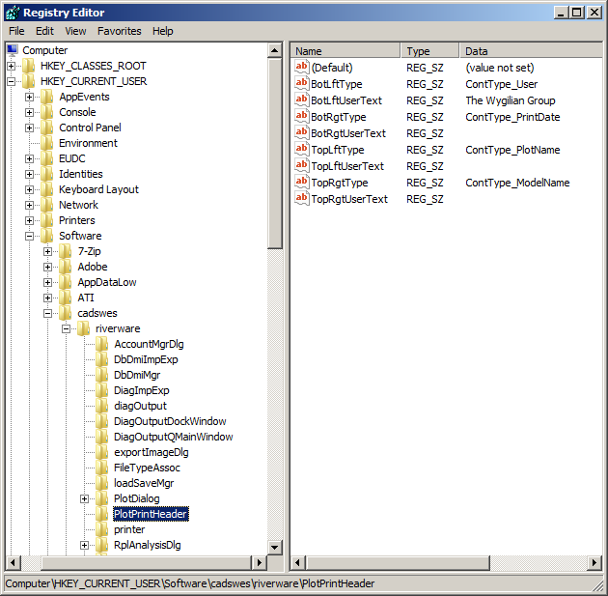

--- (end) ---