RiverWare 6.4: Accounts Manager: Rename Multiple Accounts  
Phil Weinstein, CADSWES, 8-6-2013 Initial Version, 2-15-2014 Minor Edit.

|  |  |
| --- | --- |
|  | [http://cadswes2.colorado.edu/%7Ephilw/2013/Accounting/RenameAccts/2013-08-06/AcctsMgr-RenameMenuDetail2.png](http://cadswes2.colorado.edu/~philw/2013/Accounting/RenameAccts/2013-08-06/AcctsMgr-RenameMenu.png)  [http://cadswes2.colorado.edu/%7Ephilw/2013/Accounting/RenameAccts/2013-08-06/AcctsMgr-RenameContext2.png](http://cadswes2.colorado.edu/~philw/2013/Accounting/RenameAccts/2013-08-06/AcctsMgr-RenameContext.png) |

A "Rename Accounts" function has been added to the RiverWare Accounts Manager dialog. Multiple selected accounts on different objects can be set to the same name. This function is available under the dialog's Account menu and as a context menu operation.

Clicking on the "Rename (Accounts)" operation shows the Rename Accounts dialog modally. This dialog displays a list of the accounts which had been selected within the Accounts Manager ...

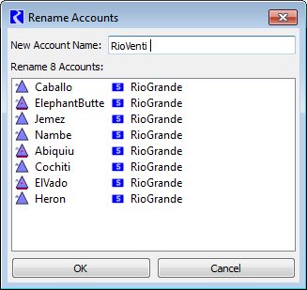

As the user types in a new account name, when the entered text represents a valid name for the listed accounts, the "OK" button is enabled. "Name collisions" and invalid characters result in an error indication shown below the list (*see images below*) -- and the "OK" button is disabled. Hitting the Enter key (when the new account name is valid) or clicking the "OK" button performs the rename function on the listed accounts and dismisses the Rename Accounts dialog.

|  |  |  |
| --- | --- | --- |
| http://cadswes2.colorado.edu/%7Ephilw/2013/Accounting/RenameAccts/2013-08-06/RenameAccts-InUse.png |  | http://cadswes2.colorado.edu/%7Ephilw/2013/Accounting/RenameAccts/2013-08-06/RenameAccts-BadChar.png |

|  |  |  |
| --- | --- | --- |
| Renaming multiple accounts on a single object is invalid. This error condition is also indicated with an error message (*see image to the right*).  As before, individual accounts can also be renamed within their respective "Open Account" dialogs. Operating the Accounts Manager's "Rename Accounts" function updates any open Open Account dialog -- even if an unapplied account name change exists in that dialog -- such a change is effectively cancelled (overridden). |  | http://cadswes2.colorado.edu/%7Ephilw/2013/Accounting/RenameAccts/2013-08-06/RenameAccts-SameObj.png |

**Technical:** The new Rename Accounts dialog is implemented with the following new Qt4 C++ and Designer UI source files. The dialog fully implements the account rename operation (i.e. this isn't just a GUI for an operation implemented in the Accounts Manager dialog). The Rename Accounts dialog could easily be deployed from another client within RiverWare which can provide a list of accounts.

* QtAccounting\RenameAccountsDlg.cpp
* QtAccounting\RenameAccountsDlg.hpp
* QtAccounting\RenameAccountsWidgets.ui

---