**CRSS: Set-up and Running**

January 2012

***Running CRSS***

1. Copy the CRSS directory and the sub-directories to a local computer, maintaining the existing directory structure.
2. Create an environment variable **CRSS_DIR** that points to the contents of the copied CRSS directory. For example, if the CRSS directory is copied to C:\Modeling\ then the environment variable value should be C:\Modeling\CRSS
3. Environment variables can be created by going to Properties of My Computer (right click on the My Computer icon). Go to the Advanced tab and then Environment Variables. The new environment variable will not take effect if it is set while RiverWare is open. With RiverWare closed, set the environment variable, and then re-open RiverWare.

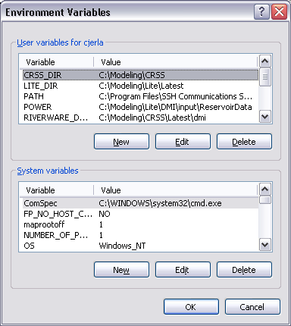

1. There cannot be any blank spaces in the path name to the copied CRSS directory.
2. The names of the sub-directories and the structure of the CRSS directory cannot be modified.
3. Perl, an interpretive programming language, must be installed to run CRSS. Perl is needed to run the input DMIs in CRSS. The input DMIs are required to run CRSS, even for a single trace. Perl can be downloaded at no cost from the website: http://www.activestate.com/products/activeperl/
4. Any output generated by running CRSS will be sent to the directory CRSS/results
   1. Output will be in the format of “RiverWare Data Files” or rdf files.
   2. Before GPAT can be used to view this output, the rdf files must be converted to Excel files. This can be done using ExcelWriter. Both GPAT and ExcelWriter are available for download from CADSWES at <http://cadswes2.colorado.edu/downloads/riverware/releases/>
   3. The type and amount of output can be customized by altering the output.control file in CRSS/control
5. **RiverWare 6.1** or higher is required to view or run this version of CRSS

***Contents of CRSS Directory Required to Run CRSS***

control

* ***Output.KeySlots.NoSalt.control*** specifies the slots that are output from the model, the name of the file where that output is stored and the location of that file. This can be modified or a new output.control file can be referenced depending on the slots that are desired to be outputted.
* ***Output.KeySlots.wSalt.control*** specifies the slots that are output from the model, the name of the file where that output is stored and the location of that file. This can be modified or a new output.control file can be referenced depending on the slots that are desired to be outputted. This control file includes salinity output and can be used when water quality is activated in RiverWare.
* ***hydrologicIncrement.Rotate.control*** specifies a slot is rotated each run during a multiple run. This slot is an integer representing the trace number and is used to compute the Powell inflow forecast
* ***NatFlowSalt.control*** specifies the 29 natural flow and salt slots that the data are loaded to contained in dmi/NFSinput (below)
* ***DPNatFlowSalt.control*** specifies the 29 natural flow and salt slots that the direct paleo data are loaded to contained in dmi/DPNFSinput (below)

dmi

* the directory ***NFSinput*** contains 103 sets of natural flow and salt input for each of the 29 natural flow slots. The natural flow sets were generated by applying the ISM to the 1906-2008 hydrology
  + the Scripts directory contains a Perl script that loads the data from the appropriate numbered trace folder depending on which trace the model is currently simulating
* the directory DP***NFSinput*** contains 1 set of natural flow and salt input for each of the 29 natural flow slots. The natural flow sets were generated based on the (762-2005) reconstructed paleo hydrology published by Meko et al., 2007.

model

* the current model

ruleset

* a ruleset that assumes operations revert to the Shortage/Coordinated Operations Final EIS No Action Alternative beginning in 2027
* the ruleset that assumes the Interim Guidelines continue past 2026

results

* the file control/Output.KeySlots.NoSalt.control specifies that the output from a multiple run will be written here