Unit Converter Enhancement Plans

- Phase 1:Convert current Unit Converter dialog to QT
- This was finished 8/7/2007 and is currently being peer reviewed by Bill
- Screen shot below: Functionally equivalent to old dialog

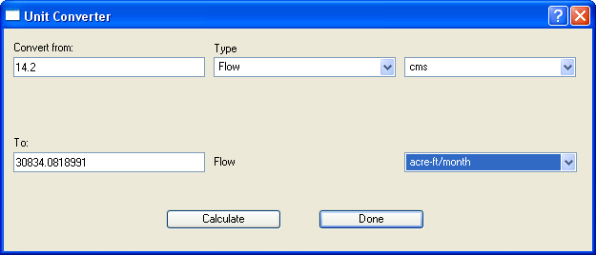

- Phase 2:Enhance Dialog to allow selection of Rate in conversion
- if unit->isbyMonth a group box will be exposed which will allow the user to specify 28 day / 29 day / 30 day / 32 day month as shown below

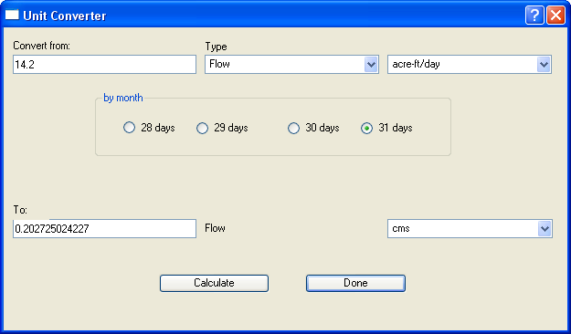

- if unit->isbyYear a group box will be exposed which allows the user to specify Leap Year or Common Year as shown below

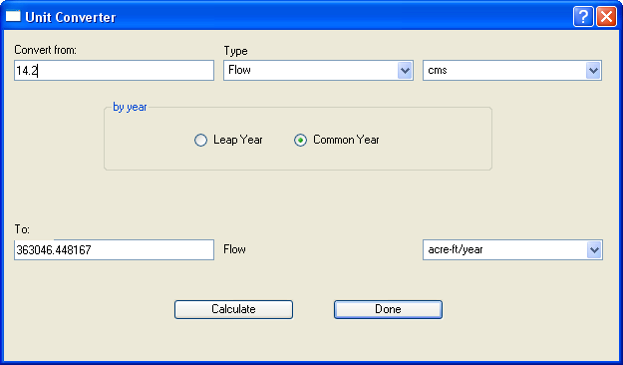

- if unit is not a rate by month or by year these group boxes will not be exposed

